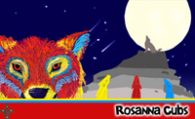

Rosanna Cubs – Joint night
with Montmorency Cubs
Tuesday 4th August, 7pm-8:30pm

Next week, we’ll be meeting with Montmorency Cub Scouts at their Hall:

- Montmorency Scout Hall – Petrie Park, Mountainview Rd, Montmorency (Down past the RSL)
– Melway 21-E6
- Full uniform or white scarf.

Come along and have plenty of fun with another Cub Pack!

Don’t miss out – see you there (if you have trouble getting there, please talk to Akela (9434 7594) and we’ll see what we can arrange)!

Regards

The Leaders
Rosanna Cub Scouts

See us at http://www.rosannacubs.org

